
CEYSAID HOLIDAYS PVT LTD

CEYSAID Internal System
Release version 1.0.0
User Manual
(01.10.2025)

CONTENT
- Introduction…………………………………………………………………………………………3
- System requirements…………………………………………………………………………..3
- Getting started
  - . User access, Roles, and privileges…………………………………………….3
  - . How to access /log out..…………………………………………………………..4

- Introduction
The CEYSAYD Internal System Web Application is a user-friendly, web-based tool designed to streamline employer management and support smooth internal communication within the company.
This guide provides an overview of the application’s key features and step-by-step instructions for completing various tasks. We recommend reviewing this document thoroughly before using the system to ensure you can make the most of its functionalities.
- System requirements
To access and use the CEYSAID internal system web application, user must meet the following requirements:
- Device: Desktop or Laptop
- Operating System: Windows 7 or later, Linux, or macOS
- Web browser (latest version of the following):
  - Google Chrome
  - Mozilla Firefox
  - Microsoft Edge
  - Safari
- Internet connection: Stable internet connection
- Addition software: PDF reader ( to open downloaded reports or documents )

- Getting started
  - User Access, Roles, and Privileges.
The users of this application are the members of Ceysaid Holidays. The Admin of the system is responsible for creating user profiles and assigning appropriate roles. Each role comes with specific rights and responsibilities that determine the level of access a user has within the system.
The table below outlines the different user roles and their corresponding privileges.

Types of roles | Access
Admin  Management  Sales  Operations | Responsible for adding new users, updating profiles, modifying access rights, and removing users. The Admin has full system privileges, including all actions available to other user roles.  Can create and manage user accounts, update user roles and information, and organize group tours. Management has elevated rights but with fewer privileges than the Admin.  Responsible for making sales and recording sales details in the system. Sales data is submitted to higher levels (Management/Operations) for further review.  Reviews and approves sales transactions submitted by the Sales team. The Operations team ensures accuracy and final approval before execution.

  - How to access /log out

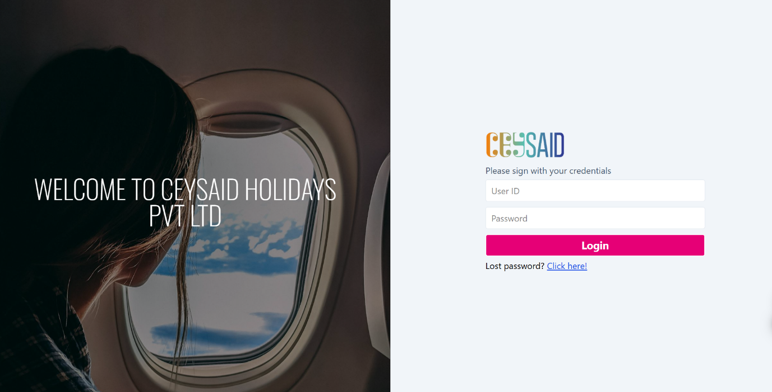

The system allows users to log in using their email and password. At the beginning, the administrator provides each user with a default username and password..

Example:
Username: ceysaid01
Password: ceysaid01
After the first login, users are encouraged to change their password for security purposes.
If a user forgets their password, they must use the “Forgot Password” option and contact the administrator for assistance.
Once logged in, users can change their password at any time without requiring admin approval. The interface for this functionality is shown below.
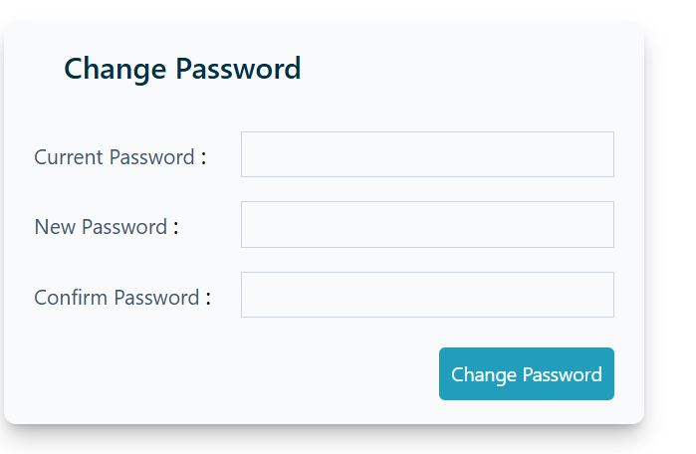
Users can change their password by entering their current password, followed by typing the new password twice (to confirm and avoid mistakes), as in standard systems.

At the top-right corner of the interface, the username is displayed with a drop-down menu. This menu includes a Logout option, allowing users to securely exit the system.
(1)
Hover drop down menu

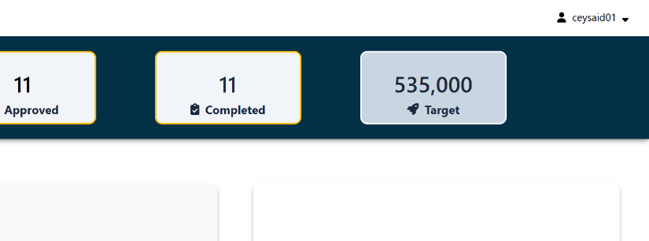
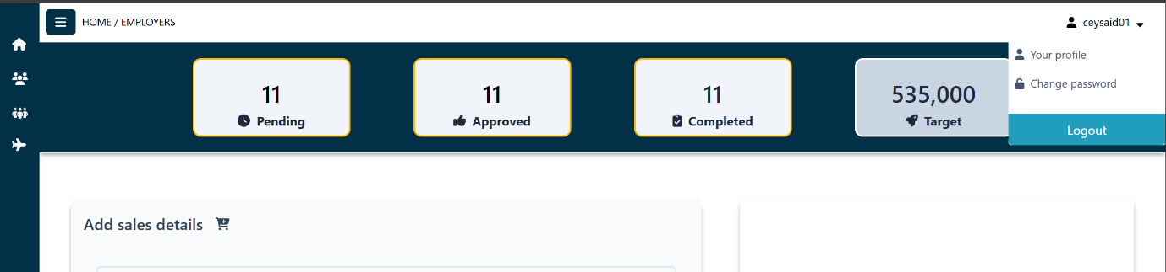
(2)
Press logout button

Additionally, another Logout button is available at the bottom-left corner of the interface, providing quick access to exit the system.
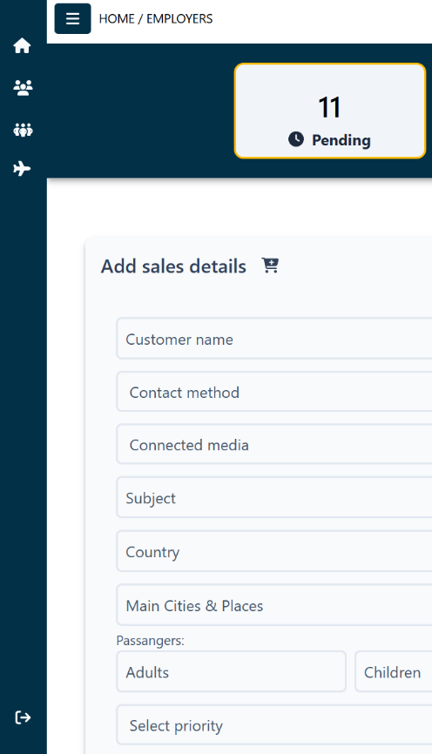
Press logout button

